Project Title:

**E-Commerce & Inventory Tracking**

Problem statement:

An online store struggles to track customer orders and manage stock availability. They need a Salesforce solution that integrates with e-commerce platforms, manages customer orders, updates inventory automatically, and provides reports on best-selling products.

Implementation:

**Phase 1: Problem Understanding & Industry Analysis**

* **Requirement Gathering:**
* Track products, orders, customers, and inventory levels.
* Automate stock reduction & low-stock alert.
* Provide dashboards for sales & inventory insights.
* **Stakeholder Analysis:**
* Customers (place orders).
* Sales Team (manage orders).
* Inventory Manager (track stock).
* **System Administrator** -manages users, roles, configurations**.**
* **Business Owner/Management** - views reports, dashboards, KPIs.
* **Finance/Accounts Team** - tracks payments, refunds, invoices.
* **Business Process Mapping:**
* Customer selects product → Order created → Inventory auto-updates → Confirmation sent → Reports and dashboards generated.
* **Industry Use Case:**
* Similar to Amazon/Flipkart stock tracking.
* **AppExchange Exploration:**
* Look for prebuilt inventory/order management apps as references.

**Phase 2 — Org Setup & Configuration:**

* Setup salesforce Org
* Sign up for a **free Salesforce Developer Edition** (developer.salesforce.com).
* Choose **Sales Cloud** as the edition.
* Configure **Company Settings**
* **Company Info** → Go to *Setup* → **Company Settings → Company Information** → Fill in company name, address, currency, time zone.
* **Business Hours** → *Setup* → **Business Hours** → Create working hours (e.g., Mon–Fri 9 AM – 5 PM).
* 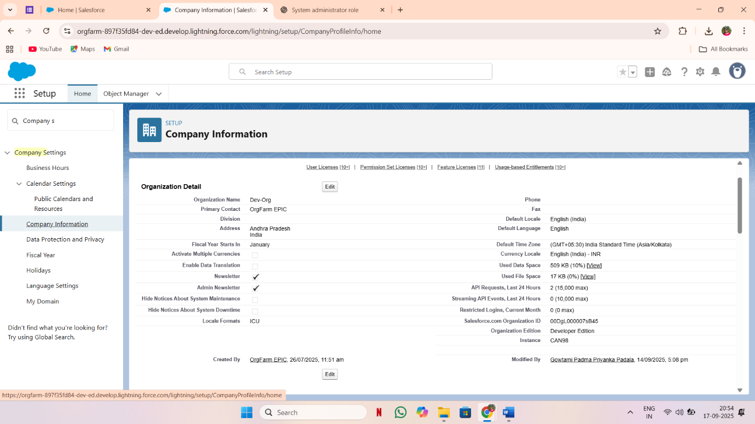**Holidays** → *Setup* → **Holidays** → Add public holidays (these can be used in escalation rules).
* Create **Users, Roles, Profiles**
* **Users** → *Setup* → **Users → New User**
  + Example: *Sales Rep, Inventory Manager, System Admin*.
* **Roles** → *Setup* → **Roles → Set up Roles**
  + Example hierarchy:
    - CEO/Admin (top)
      * Sales Manager
      * Inventory Manager
* **Profiles** → *Setup* → **Profiles**
  + Use *System Administrator* profile for admin.
  + 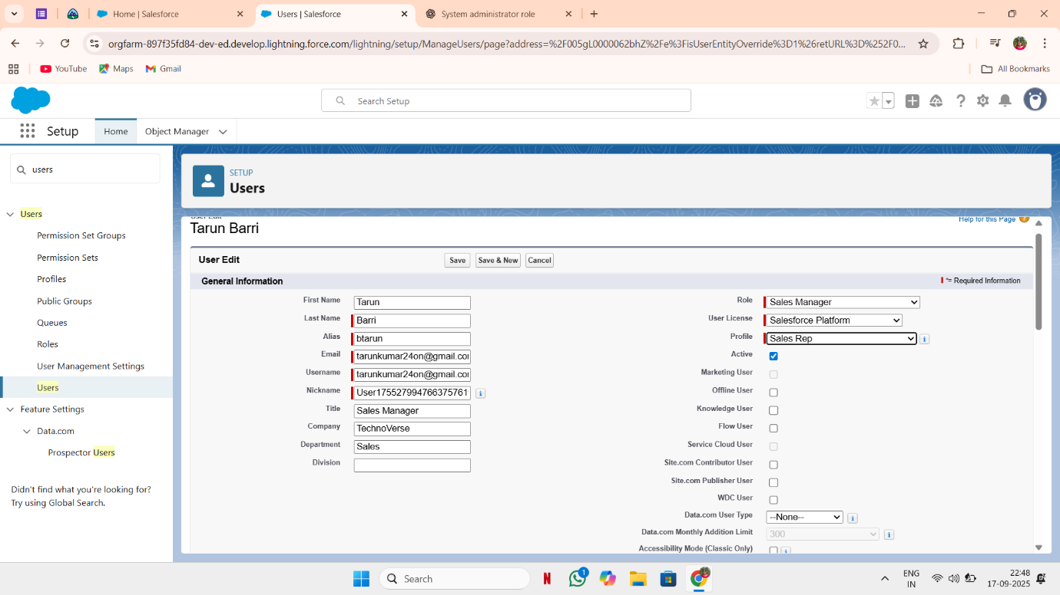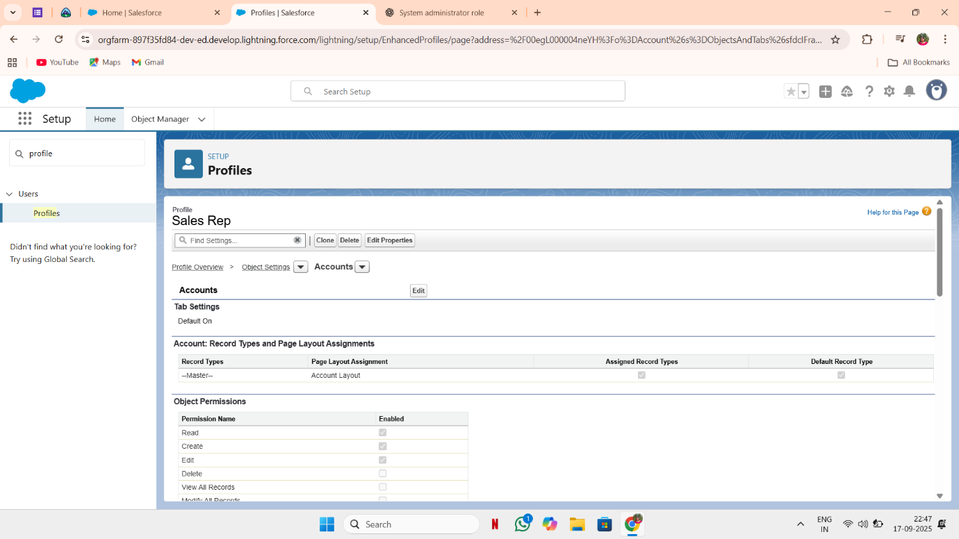Clone *Standard User* profile to create *Sales Rep Profile* and *Inventory Manager Profile* with appropriate permissions.
* Define **Permission Sets**
* *Setup* → **Permission Sets → New**
  + **Order Approvers** → Add “Modify All” on Orders.
  + **Inventory Editors** → Add “Edit” access on Inventory objects.
* Assign these permission sets to users who need special access without changing their profile.
* Configure Sharing Settings:
* **Organization-Wide Defaults (OWD):**
  + *Setup* → **Sharing Settings** → Set *Orders = Private* (only owner sees records).
* **Sharing Rules:**
  + Example: Create a rule to share *Orders* with *Sales Managers* so they see all team orders.
  + Use these as required by the process.
* Enable SecuritySettings
* **Login Access Policies** → Allow admins to log in as users for troubleshooting.

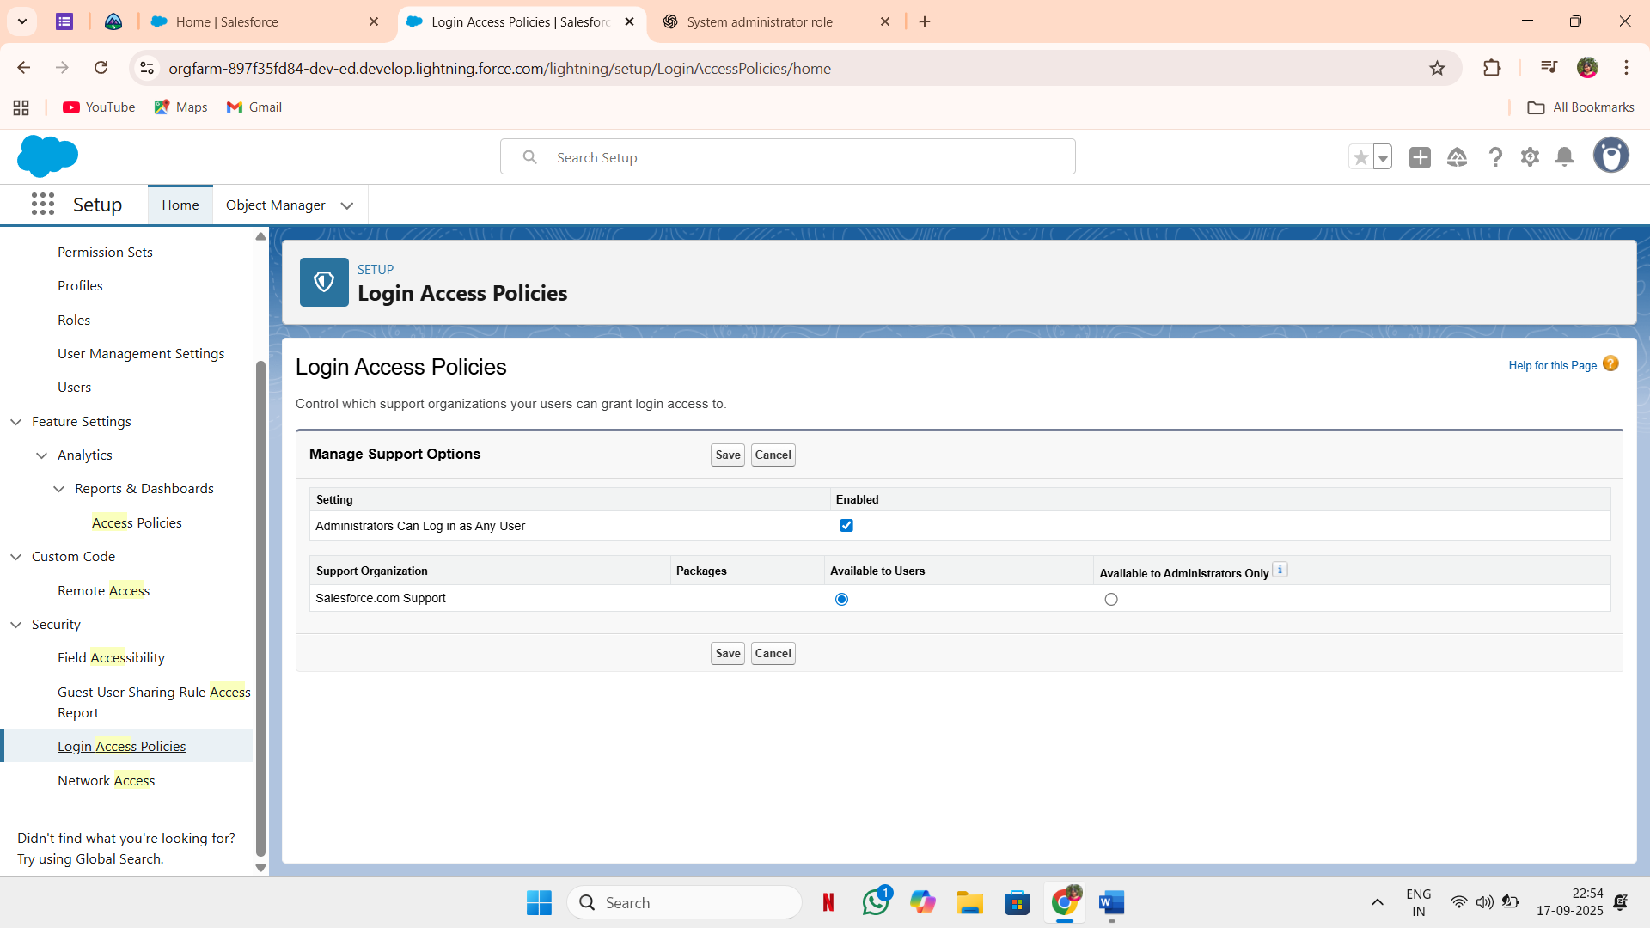

* **MFA (Multi-Factor Authentication):**
* Enable from *Setup* → **Identity Verification → Multi-Factor Authentication**.

Adding multi factor authentication for users using permission sets

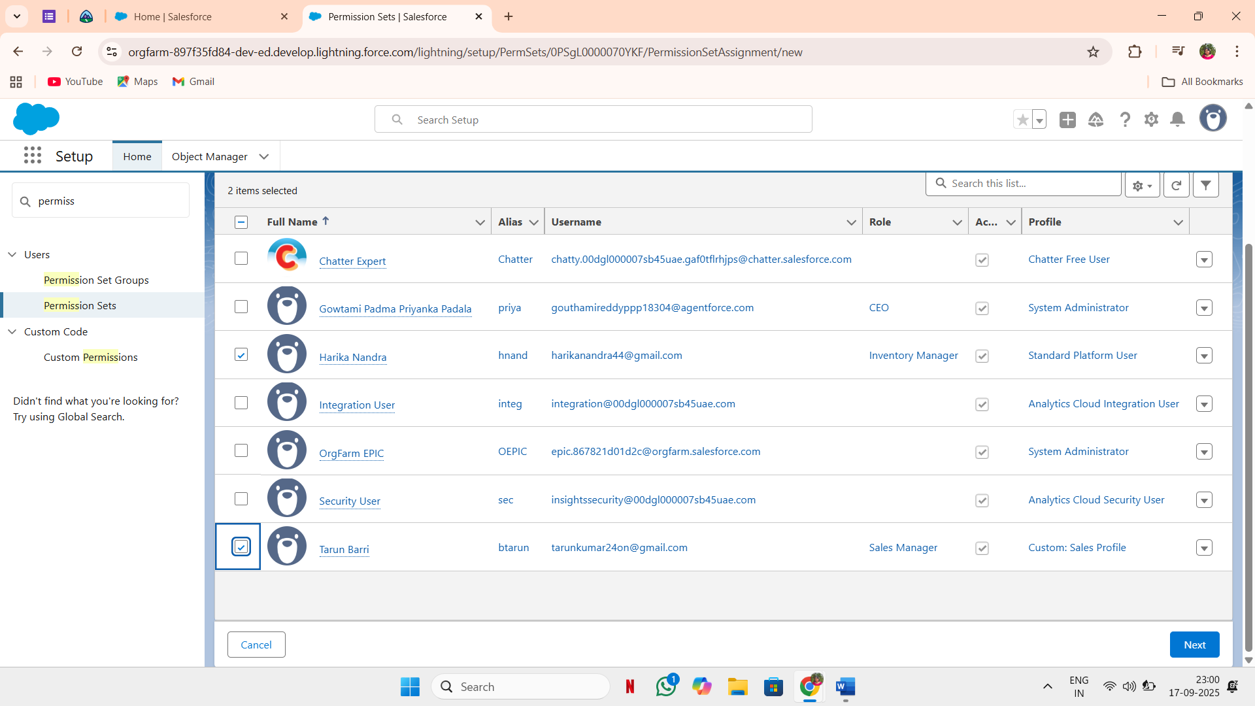

* **Audit Trail:**

*Setup* → **View Setup Audit Trail** → Monitor configuration changes

**Phase 3: Data Modeling & Relationships**

Step 1: Identify Core Business Entities

* E-Commerce Objects:
  + Product (standard: Product2)
  + Pricebook / PricebookEntry (for pricing control)
  + Order / OrderItem
  + Customer (standard: Account & Contact)
  + Cart (custom object if required before checkout)
  + Payment (custom object)
* Inventory Objects:
  + Inventory Item (custom object linked to Product2)
  + Warehouse / Location (custom object)
  + Stock Movement (custom object for tracking stock-in/stock-out)
  + Supplier / Vendor (custom object)

Step 2: Create Standard & Custom Objects

* Use Object Manager in Salesforce Setup.
* Extend standard objects (Account, Contact, Product, Order).
* Create custom objects like:
  + Warehouse__c
  + Inventory_Item__c
  + Stock_Transaction__c
  + Payment__c

**A. Standard Objects to Leverage**

1. **Account** – Represents **customers**
   * Example: *Amazon Seller*, *Customer John Doe*.
2. **Contact** – Represents people tied to Accounts.
   * Example: *Customer’s shipping contact info*.
3. **Product2** – Represents your products.
   * Example: *iPhone 15, Samsung TV*.
4. **Pricebook / PricebookEntry** – Holds pricing.
   * Example: *Retail Pricebook, Wholesale Pricebook*.
5. **Order / OrderItem** – Captures purchase details.
   * Example: *Order #1234 with 3 OrderItems*.

**B. Custom Objects to Create**

**1. Warehouse__c**

* Stores warehouse locations.
* Key Fields:
  + Name (Auto-number: WH-0001, WH-0002…)
  + Location__c (Text/Geolocation)
  + Manager__c (Lookup → User)

**2. Inventory_Item__c**

* Tracks stock for each product in each warehouse.
* Key Fields:
  + Product__c (Lookup → Product2)
  + Warehouse__c (Lookup → Warehouse__c)
  + Available_Quantity__c (Number)
  + Reorder_Level__c (Number)
  + Last_Updated__c (Date/Time)

**3. Stock_Transaction__c**

* Logs movements in/out of inventory.
* Key Fields:
  + Inventory_Item__c (Master-Detail → Inventory_Item__c)
  + Transaction_Type__c (Picklist: Inbound, Outbound, Adjustment)
  + Quantity__c (Number)
  + Transaction_Date__c (Date/Time)

**4. Payment__c**

* Captures payment details for an order.
* Key Fields:
  + Order__c (Lookup → Order)
  + Payment_Method__c (Picklist: Credit Card, UPI, Net Banking, COD)
  + Payment_Status__c (Picklist: Pending, Completed, Failed)
  + Transaction_Id__c (Text)

**Create the Lightning App (Setup → App Manager → New Lightning App)**

* App Label: **ECommerceInventory**
* App Name: ECommerceInventory
* Description: E-commerce + Inventory Management
* Branding: Set logo & color
* Navigation Style: Console or Standard (Console recommended for Inventory Manager)
* Add Navigation Items (tabs): Accounts, Contacts, Products, Price Books, Orders, Payments, Warehouse, Inventory Item, Stock Transaction, Cart, Reports, Dashboards
* Assign Visibility: Choose which profiles can see the app (Sales Rep, Inventory Manager, Admin)

**profiles, Permission Sets & Access**

1. Create two Permission Sets: Inventory_Manager_PS, Sales_Rep_PS.
2. For Inventory Manager PS: full Read/Create/Edit/Delete on Warehouse, Inventory_Item, Stock_Transaction, Product_Warehouse.
3. For Sales Rep PS: Read on Inventory, Create Orders, Create Payments (limited), Edit Accounts/Contacts.
4. Ensure Field-Level Security: hide Transaction_Id__c or other sensitive fields from non-admins.
5. Assign PS to test users.

**8) Page Layouts, Lightning Record Pages, Compact Layouts**

* Create Page Layouts by profile: Inventory_Manager Layout, Sales_Rep Layout
* Add related lists: Inventory Item → Stock Transactions; Order → Payments; Product → Inventory Items / Product-Warehouse mapping
* Build Lightning Record Pages: use Lightning App Builder to create a layout with Highlights Panel, Related Lists, Stock Movement component, Quick Actions (Create Stock Transaction, Adjust Quantity)

Step 4: Set Up Record Types

* For Products:
  + Record Types: *Electronics*, *Clothing*, *Grocery* (different layouts/fields).
* For Orders:
  + Record Types: *Retail Order*, *Bulk Order*.

Step 5: Design Page Layouts & Compact Layouts

* Customize layouts for each profile (Sales Rep, Inventory Manager).
* Example:
  + Inventory Manager sees stock fields (Reorder Level, Warehouse).
  + Sales Rep sees customer/order-related fields.

Step 6: Establish Relationships

* Used Schema Builder to map:
  + Account → Contact (Standard Parent-Child).
  + Product2 → PricebookEntry → OrderItem (Standard Salesforce e-commerce flow).
  + Product2 ↔ Inventory_Item__c (Lookup or Master-Detail).
  + Warehouse__c ↔ Inventory_Item__c (Master-Detail).
  + Order__c ↔ Payment__c (Lookup).
  + Stock_Transaction__c ↔ Inventory_Item__c (Master-Detail).

Step 7: Use Junction Objects

* If needed, create junction objects:
  + Example: *Product-Warehouse Mapping* if a product is stored in multiple warehouses.
  + Example: *Customer-Cart* for handling multiple customers adding items to different carts.

Step 8: Consider External Objects

* If inventory or payment data resides in an external ERP/Payment system, set up External Objects via Salesforce Connect.